Devil’s Office

X-Statement:

* Just Act Natural (Blending into AI)
* Spy Party (Do tasks to avoid being killed by a sniper)
* Assassin’s Creed Multiplayer (Mix of Characters)
* Party hard (Level Design)

Genre: Local multiplayer social deduction

Description:

A multiplayer game, 2 to 4 players. Players need to kill each other by backstabbing. ﻿ ﻿The game will have many NPC in the scene, and they will have appearances very similar to each other. ﻿ ﻿Players and NPC’s will be doing tasks all around the level. ﻿The game environment will be an office in a small or medium size depending on the quantity of players in the match.

Mood board:

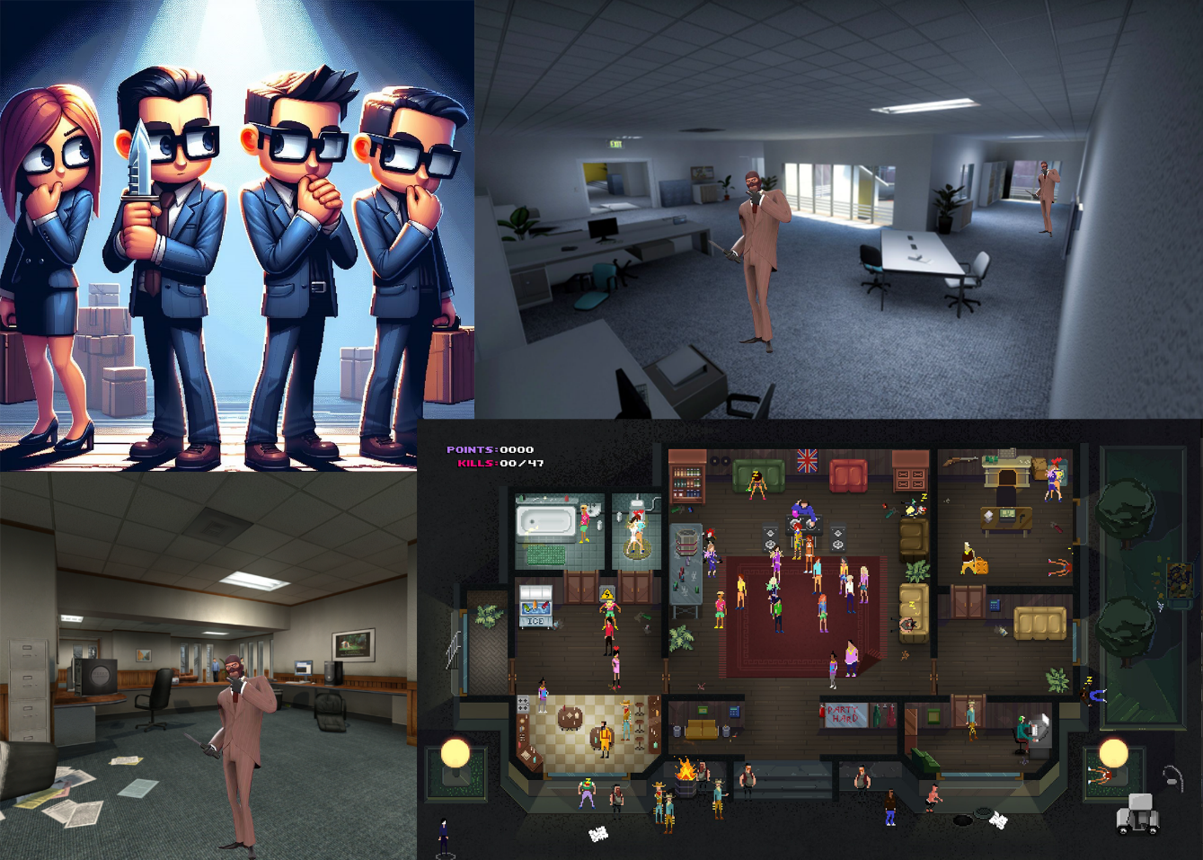

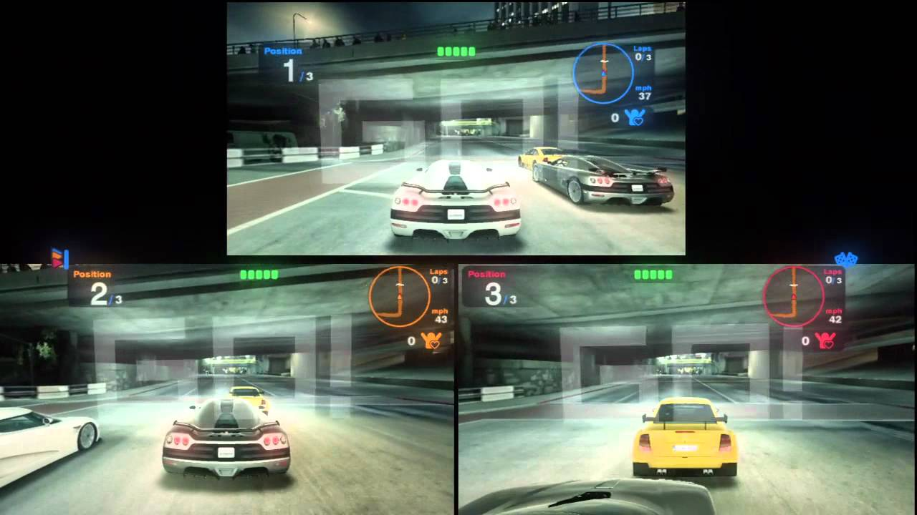Camera: First-Person Split Screen

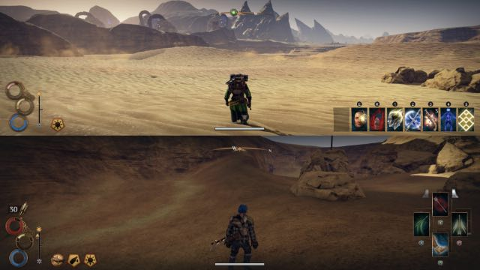

Control:

Controllers: Grid movement each square is 1 unit, that is going to make the IA look alike the players;

Move 1 unit Forward (Left Analog Stick), move camera left and right rotate 90 (Right Analog Stick), attack 1 unit range (Rt), and interact 1 unit range (Lt). Skills (North, South, East, West Buttons)

(If we have LAN) Keyboard and Mouse: Move Forward (W), move the camera left and right (Mouse Movement), attack (Left Mouse Click), and interact (Right Mouse Click). Skill (Space Bar)

Character: 2 bases with randomized clothes & hair for each character every time the game starts.

Hooks: Hide among the NPC while trying to find other players to backstab them before they backstab you!

Pillars:

Back Stab

AI NPC: Movement equal to the player, moving around the environment doing tasks.

Tasks: Print Devil flyers, Print shameful angel pics, (Printer), drink cold Coffee (Coffee Machine), Stamp the Devil’s face on paper, sharpen pitchfork, prank call angels, call your mom (Phone), extinguish bodies (only shows up if you kill NPC). Tempting mortals (Computer), glorifying the devil (Painting on the wall), Spawn new politicians in the world (Computer)

Stealth: hiding among the office workers

# Win Condition:

* Finish all your tasks first.
* Be the last one standing.

On Death:

* Player moves around with the same speed but no one can see them, but they can interact with stuff

# Mechanics and systems:

* Do tasks (if the player doesn’t do a task every x second an outline appears on the body)
* Movement (Fixed speed forward, players can’t move sideways or backward)
* Looking (Fixed rotation speed)
* Kill
* Interact with objects (Turn off the lights, activate the alarm)
* Skills (Close your eyes, the screen gets black)

# Level Design:

* Levels with lots of rooms

# Music samples:

REF

# Hitman: Blood Money

# The Stanley Parable

# Papers, Please

# The Sims

Lists

# Stabb, People talking, Printer working, Door opening, Door closing, Cell phone ringing, People saying, good morning, People saying hello, Button click, Game Over, mine Task, Time finishing.

# Lore:

The hell needs to be managed and the place where it runs is in the devil office. It is a mix of management, accountability, marketing and bank where the devil manages the bad stuff their devils needs to do.

Obviously, there is not a peaceful place wo work, the devils are very jealous and they normally kill each other to try to be promoted.

But how this place is very "special", when you die, you just wake up in another day to work in the devil's office again.